# IOS live workflow

**Note :** For apple id password contact sundar sir or manoj sir

### Step1:

- Login into apple developers > after signing in with apple id you’ll find this below page

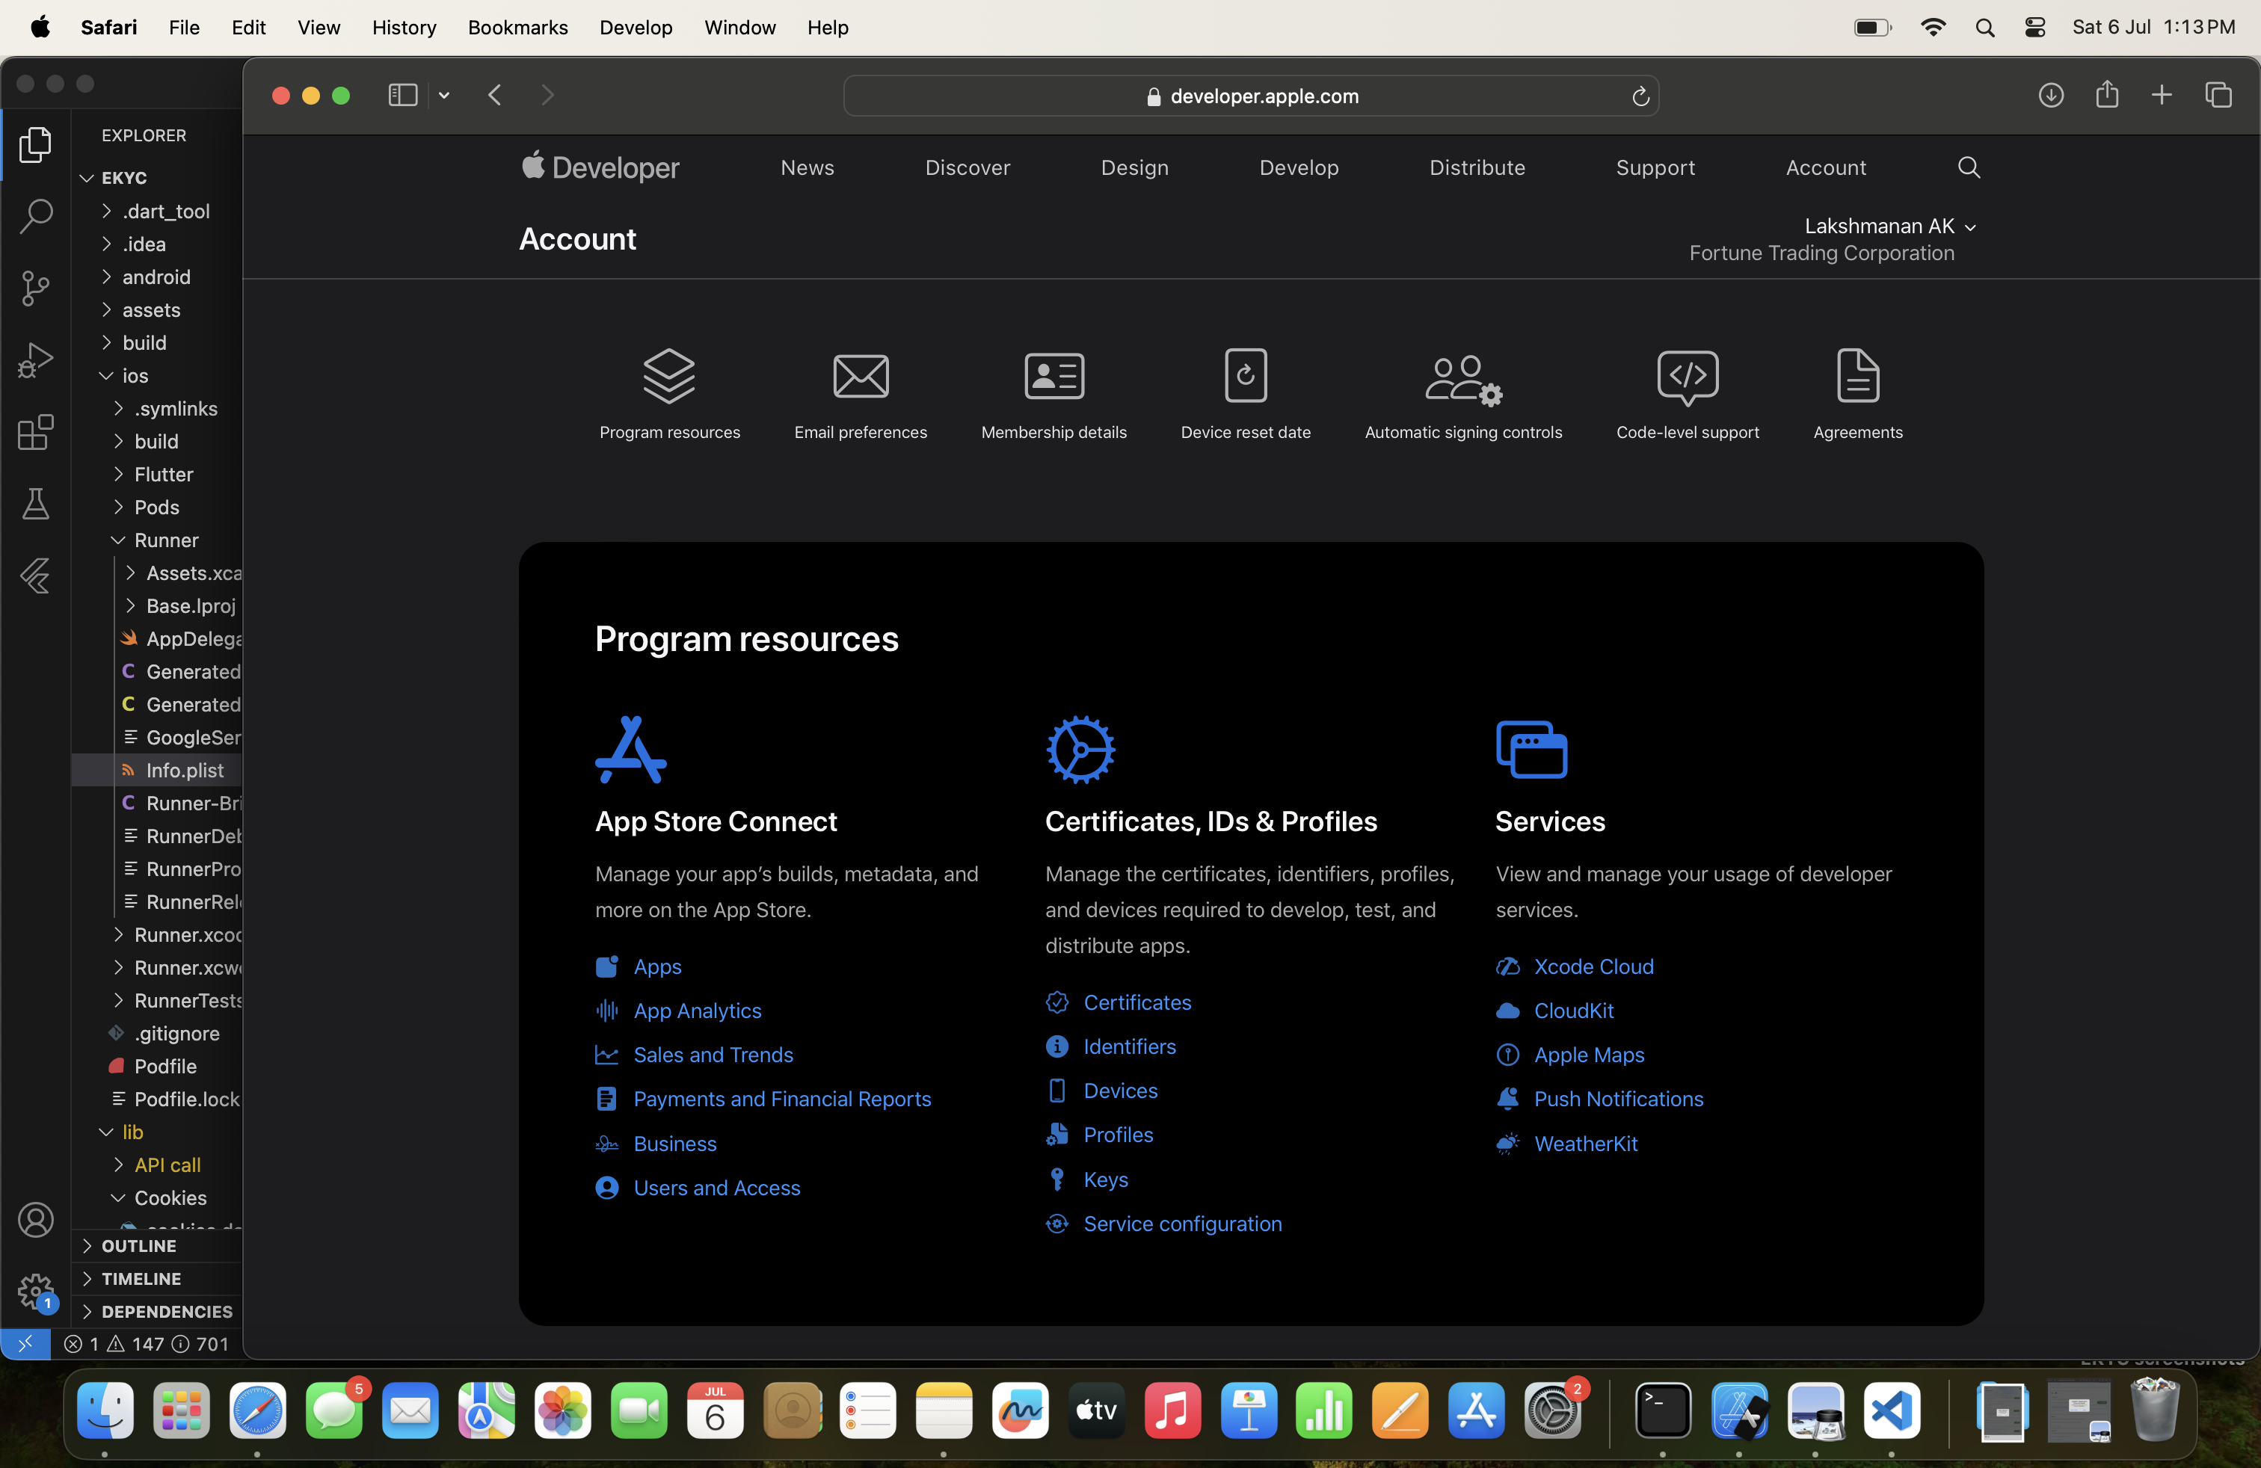

- Click the "certificates” text button shown in above image

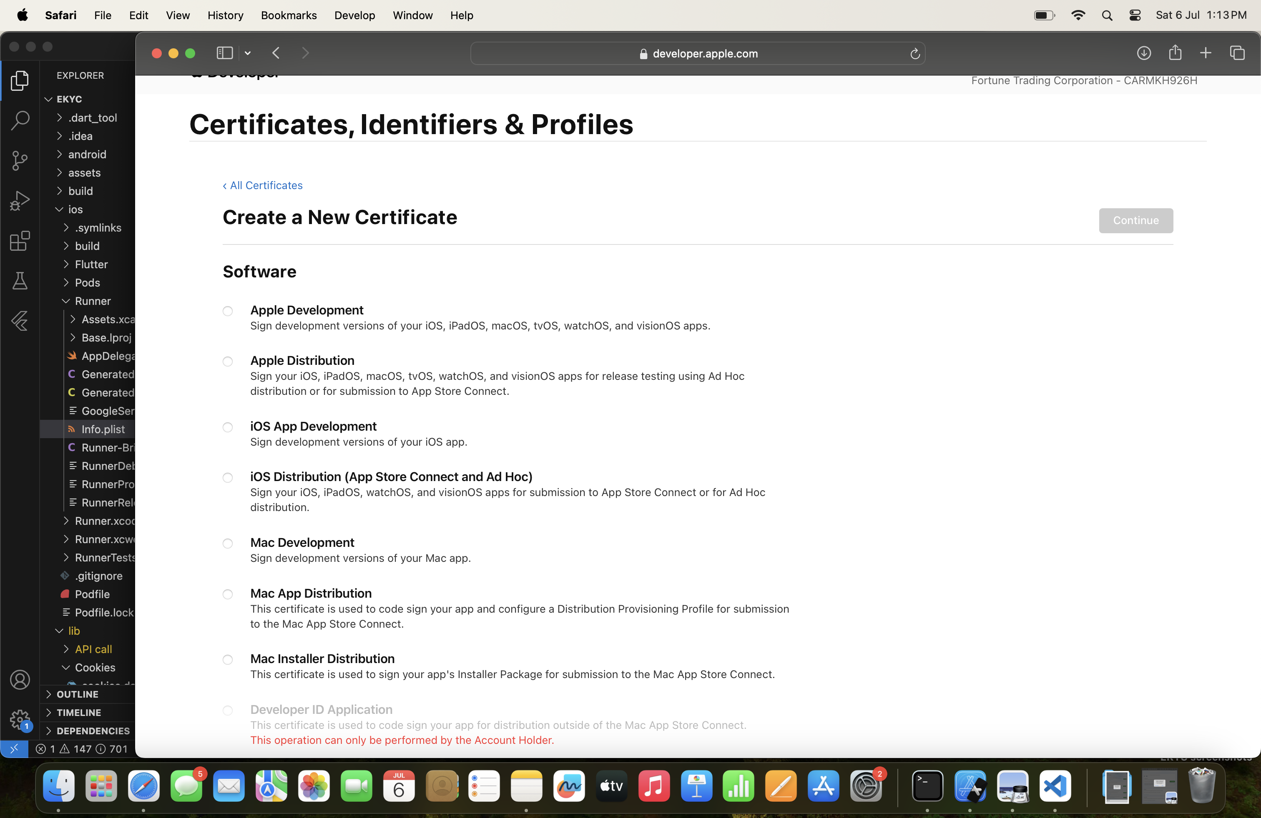

- You’ll be routed to the above image ,click add certificates follow the process and create a certificate

-after creating certificate come back to home page and click “identifiers” which is below the “certificates”

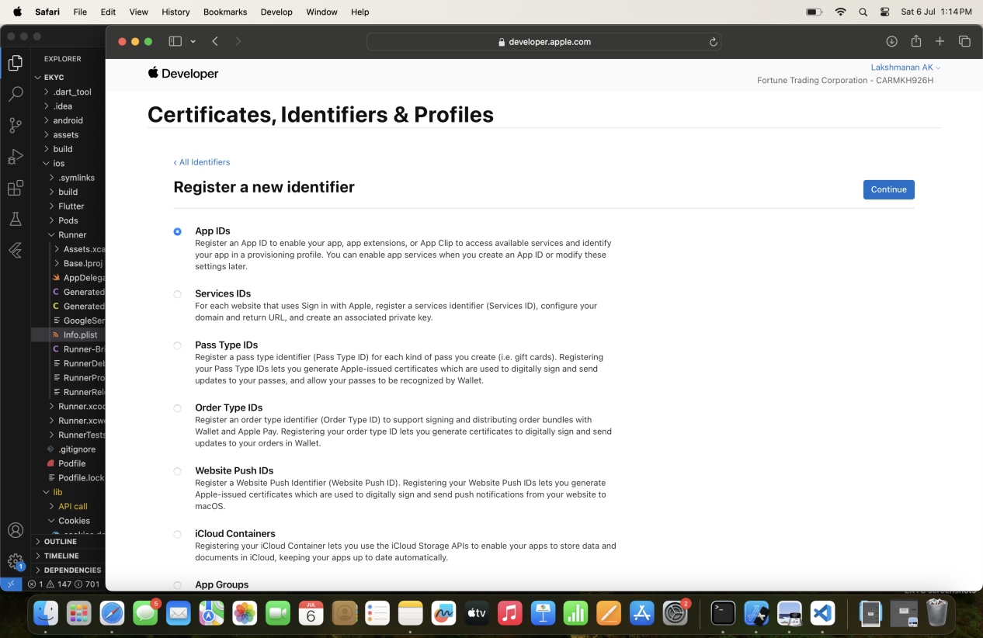

- You can find a above page click continue button!

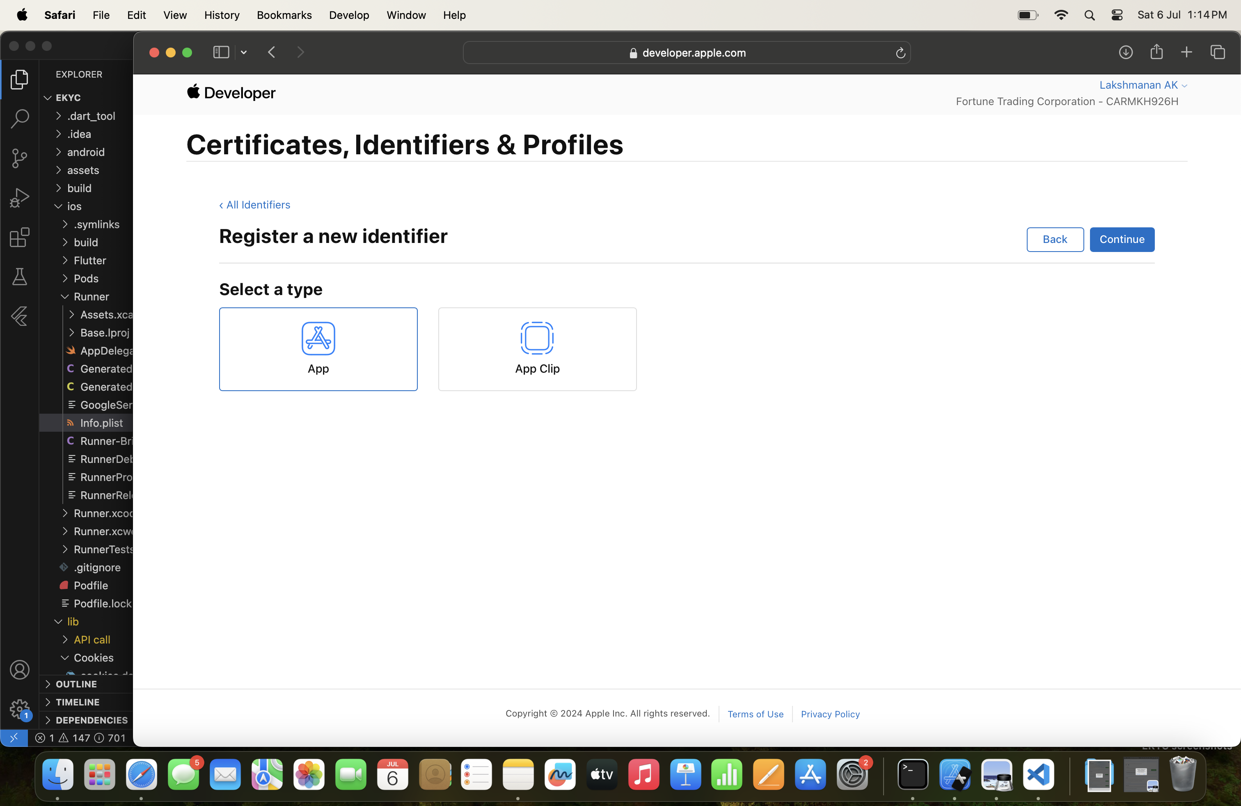

- Select “App ” tab and click continue

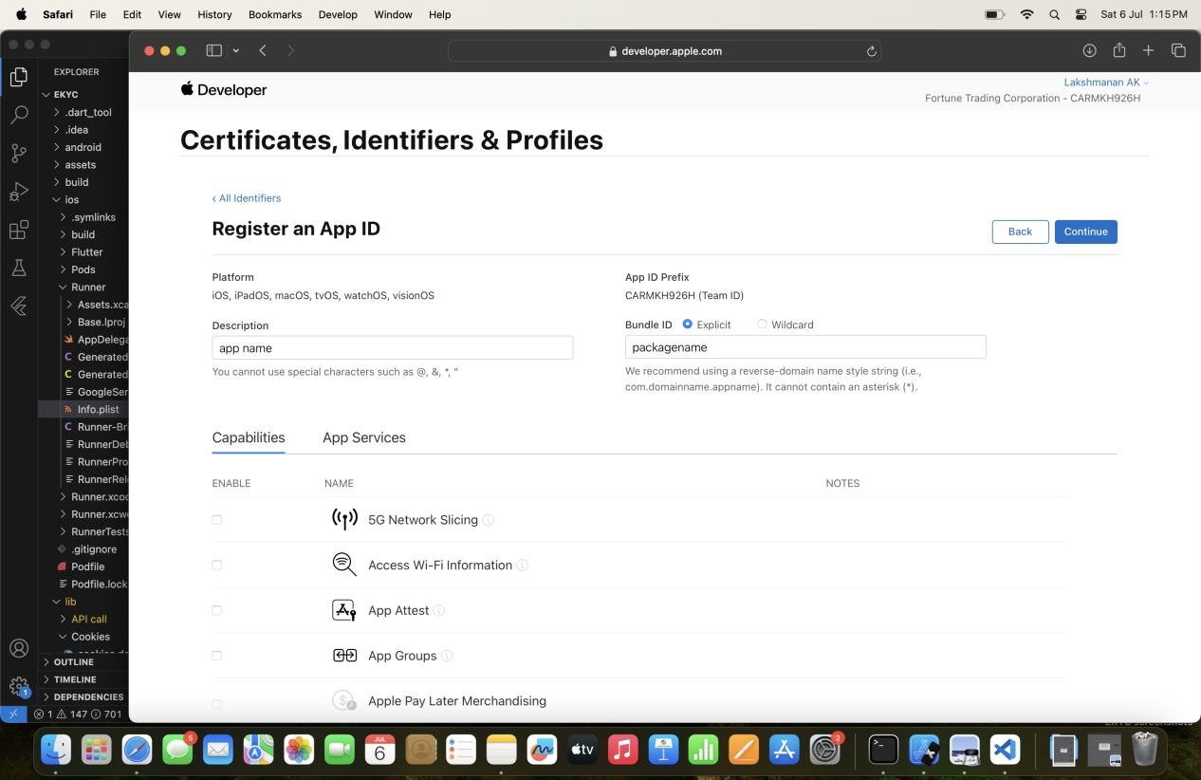

- add a app name in description field , enter package name in Bundle id field, enable required field in capabilities,then click continue app will be created

Eg we enable push notification for instakyc app

### Step 2

- After creating certificate and identifier

- go to vs code target ios folder and open it with xcode and run it

- after a sucessfull run in xcode take IPA build.

$command(flutter build ipa --release)

- open transporter app

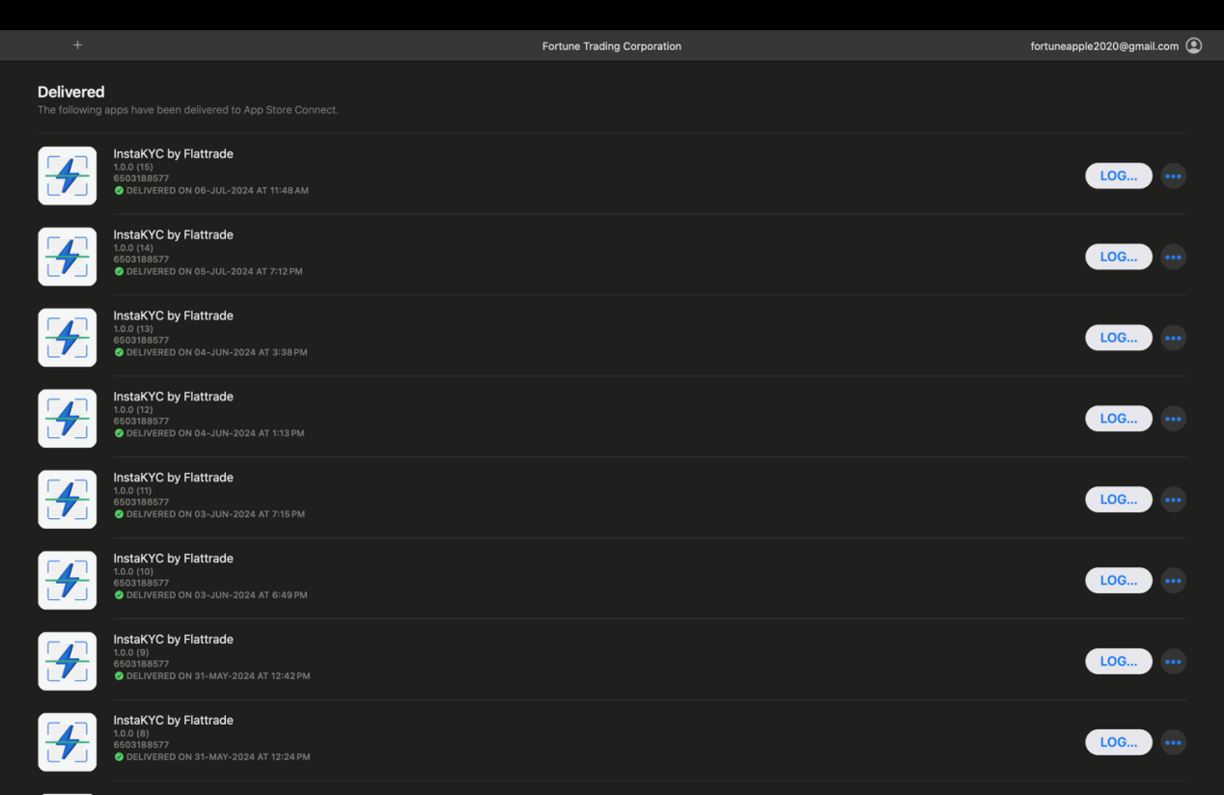

- After signing in with apple id you’ll find the above page

- drag and drop the ipa file in transporter.

ipa file path(project>build>ios>ipa>filename.ipa)

- first verify and then click deliver button\

- once delivery is completed in transporter app the build will updated in app developers account!



- then open app developer website again and click apps

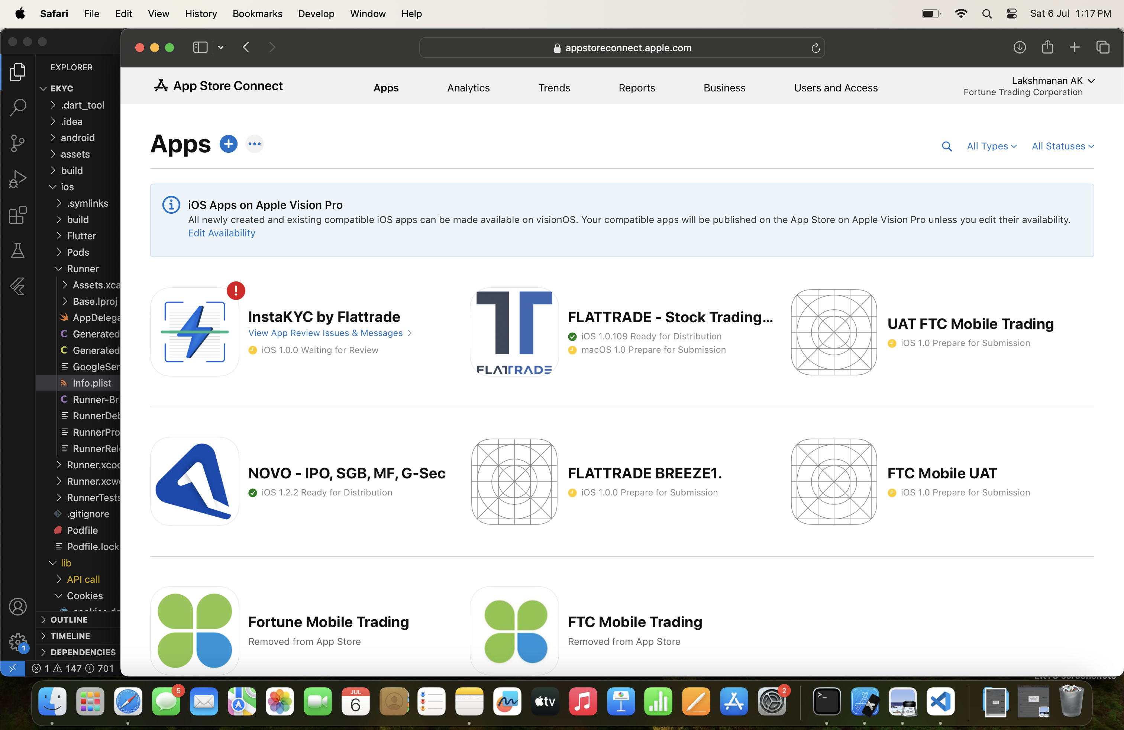

You can see the above page , after the completion of delivery in transporter we can see our app in page once you find the app click it

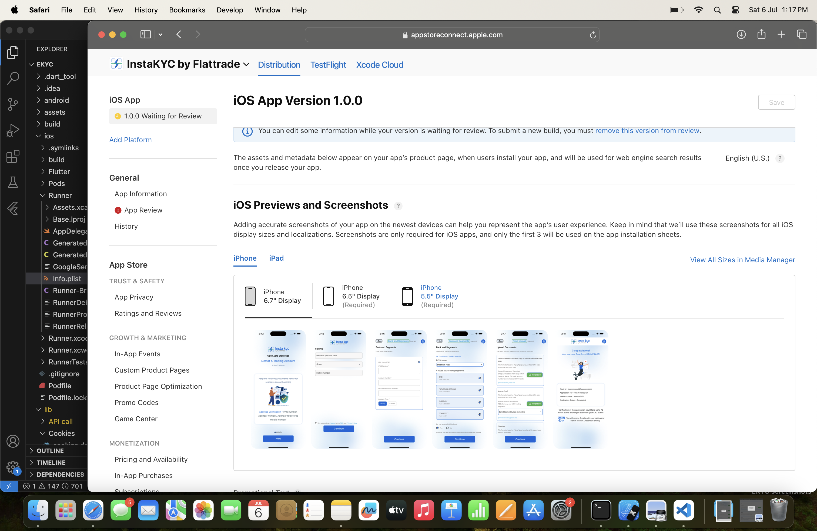

- Then you can find the above page select Distribution and fill the required fields

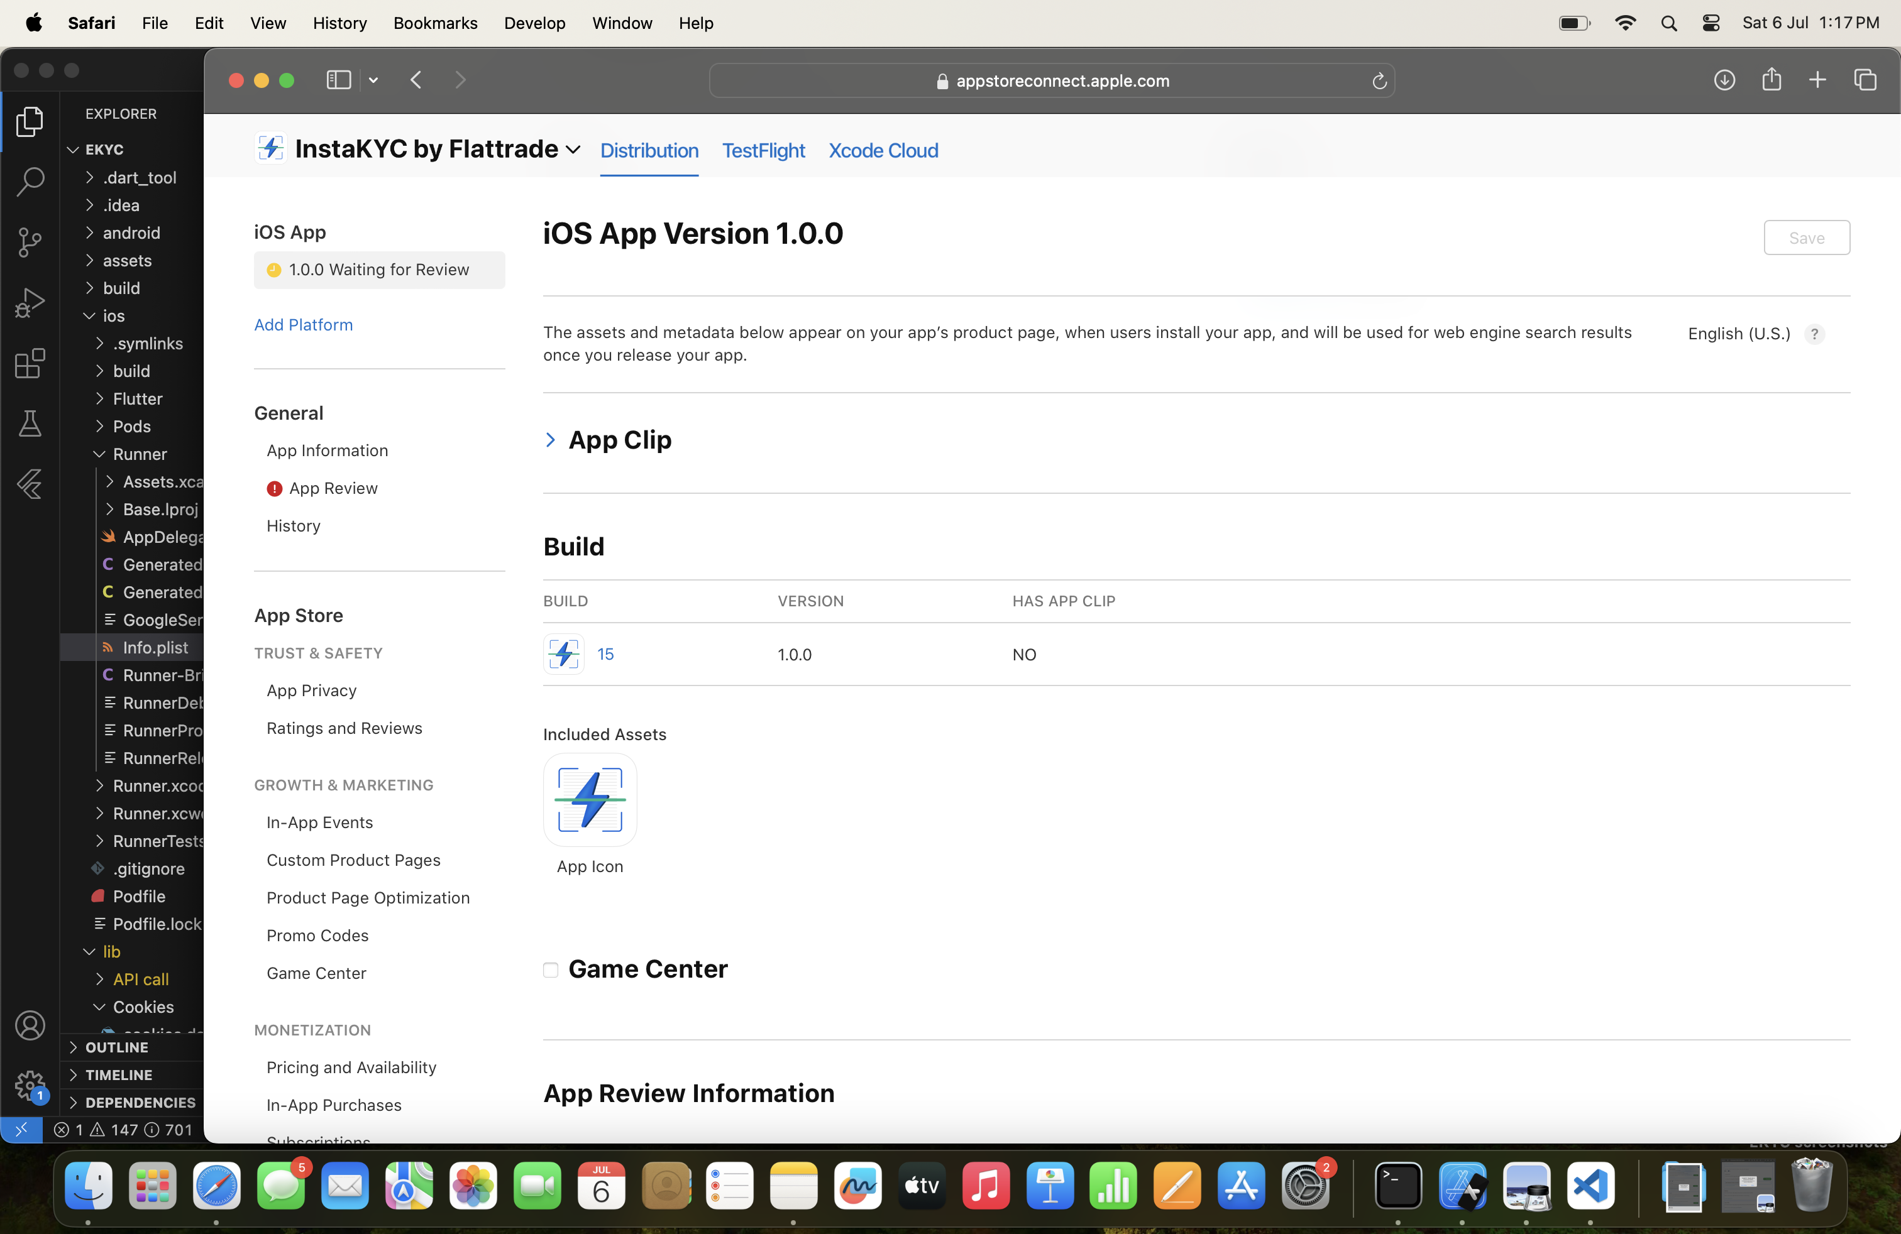

- In Build section we can see our build which is actually transfered from transporter

Select our build send it to review

-finally follow review from apple

**Test Flight:**

-Testflight is used to test our app by sending it to the registered users through test flight

- For this process you have click “text flight” tab which is next to Distribution tab in apps page

- An scroll down on the left side of the screen select ($projectname developers team >select the build and send it for testing)

- Registered users will get the mail and build will be send to testflight mobile app of registered user there they can download and test it